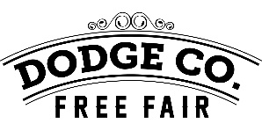
Dodge County Grandstand Schedule
Advanced Grandstand Tickets Sold Daily 2:00 pm to 5:00 pm in the Entertainment Center
Two Bicycles will be given away each night!

Wednesday July 14th
6:00 pm • Enduro Races
Fireworks to Follow

Thursday July 15th
7:00 pm • Thunderbird Open Stock Car Races

Friday July 16th
7:00 pm • Rice Bull Riding Challenge
Intermission to include Mutton Busting

Saturday July 17th
10:00 am • Free Antique Tractor Pull
5:30 pm • Kids Power Wheels Derby
6:00 pm • DC Championship Demolition Derby

Sunday July 18th
3:00 pm • Dodge Mayhem Trailer Races

